

Lighting and Rendering in the Unity Game Engine

Final Year Report

Awais Tasleem SGB849 @00514972 | Final Year Project | 3/7/2023

# Abstract

Table of Contents

Abstract 1

Table of Figures 2

Introduction 2

Motivation 3

Overview of Report 3

Requirements and Design 3

Requirements 3

Requirement 1 - Player Movement and Interaction 3

Chaining Moves 4

Momentum 4

Trajectories and Physics 4

Environmental Integration 5

Decision Making 5

Requirement 2 - Lighting Effects and Shadows 5

Requirement 3 – Graphics 6

Requirement 4 – Game/Map Design 6

Requirement 5 - Security Features 7

Design 8

Use Case Diagram 8

UML Sequence Diagram 9

UML Class Diagram 10

Wireframe of UI 11

Summary 16

Development and Implementation 16

Sprint 1 – MVP for Demo 16

Testing and Analysis 16

Critical Evaluation 16

Conclusion 16

References 16

Appendix a: https://www.youtube.com/watch?v=bgyrrjmavy4&t=15s 0

Appendix b: PlayStation 5 Box 0

Appendix c: Call of Duty: Modern Warfare 2 2022 Battle Pass page: 0

Appendix d: Battlefield 2042 Battle Pass page: 1

Appendix e: Shark Cash Card pirces and link to the website - (rockstargames.com) 1

Appendix f: GTA 5 Mod Menu 2

Appendix g: Figma - Figma Downloads 2

Appendix h: Draw.io link - diagrams.net 2

# Table of Figures

Figure 1: Use Case Diagram 9

Figure 2: UML Sequence Diagram 10

Figure 3 - UML Class Diagram 11

Figure 4 - Overall View in Figma Studio 12

Figure 5 - Main Menu 12

Figure 6 - Play Menu 13

Figure 7 - Free Roam 13

Figure 8 - Demo Mode 14

Figure 9 - Settings Menu 14

Figure 10 - Graphics Submenu 15

Figure 11 - Sound Submenu 15

Figure 12 – Logs 16

# Introduction

The main aim of this project is to understand how lighting and rendering works in games and how it can help the gameplay and atmosphere for the player. I will also try to learn how the new Unity Render Pipeline works for lighting to see how fast and more optimized games become so that my game can run on lots of older and slower hardware such as older graphics cards like the Nvidia GTX 750ti or even smart phones and use resources on new and faster hardware such as the new Nvidia RTX 4090 in a more efficient way to get higher quality graphics and lighting.

I will hopefully use lighting in a way that enhances the gameplay visually where it can be used in guiding the player or to show items or places of interest and to make the game look more realistic and, I will be able to learn how to optimize my game to run on different platforms.

The second aim for this project is to also understand the security aspect of the game industry as it is becoming a bigger issue day by day as more games are getting hacked and gamers details are being leaked such as the Sony PlayStation online hack that happened in 2011 and made Sony lose approximately $171 million (Mystic, 2019).

## Motivation

I wanted to make a game with good graphics for a long time as I have made games in the past that are on the google play store and on my website [Awais Tasleem's Portfolio (awaist7860.github.io)](https://awaist7860.github.io/Awais-Portofolio/). These games looked basic and were mostly made for smart phones. The main issue that I had when developing my games was the time needed to make them as I was in high school and college studying for my GCSE’s and A-Levels, I did not have enough free time to make the games look higher quality and with better graphics. This project will allow me to spend more time on learning more about game development and the different practices that are used in the industry and to improve the skills that I have already learnt over the years whilst developing games to make a higher quality game with better game mechanics.

## Overview of Report

# Requirements and Design

## Requirements

This part of the report will talk about what requirements are required for the project and it will also give a reason as to why they are important, it will also give a method to complete the requirement.

### Requirement 1 - Player Movement and Interaction

Character movement and interaction in games is a common thing and is usually overlooked by games, but designing a great character movement mechanic can make the gameplay more fun and enjoyable for the user (Run, 2019). If the character movements mechanics are very bad and cumbersome to use, this will annoy players and stop them from having fun in the game, or they may stop playing the game all together which could have a huge negative impact on the game development company and their future projects and future revenue.

Movement and interaction mechanics are the main way that allows a player to move around and interact and get immersed in the game world (1-up, 2021). This is very important for any game from the first Mario World game with its 2D side scroller gameplay to today’s huge 3D open world games such as Horizon: Forbidden West. These mechanics allow the player to walk, run and jump around the game world, also it allows them to interact with the world by jumping on objects to gain coins in Mario World, and to interact with other characters in the game in Horizon: Forbidden West to gain more knowledge about the story from other AI characters.

Character movement will be an essential part to the showing the lighting and Rendering of the Unity game Engine as the player will need to be able to move around the game world so that they can see the way the light is rendered in the game and how the player movement effects the lighting and the performance of the game.

There are many different factors to look at when designing a good movement system for a game. Below are 5 factors that are very important to the core of most games currently on the market.

#### Chaining Moves

Chaining moves together increases the depth of simple key presses (1-up, 2021). For example, in fighting games like Injustice: Gods Among Us, when the player taps the X button once, it only does a simple punch, but if the player presses the up arrow and then presses the X button, the player will jump in the air and punch the enemy character. The simple action of chaining moves together gives the player more option of exploring the game world and interacting with the game world. It also rewards more skilled player as they can do higher jumps or longer jumps with greater efficiency and fluidity in movement (1-up, 2021).

#### Momentum

Momentum is the feeling of speed and non-stop movement for the player. This allows the movement of the game to feel fluid and smooth to the player (1-up, 2021). This makes the player feel like they are running through the game world, which increases the emersion of the game world on the player.

#### Trajectories and Physics

Another important part of having a well thought out movement system is having realistic or believable physics system. This part allows developers to make the movement system easier for the gamer to understand as it feels like real life to them which allows to make better movement decisions in the game (1-up, 2021).

One example where the physics of the real world are used to affect the movement system in a game is in the Spider Man game on PlayStation. The player moves around the city of New York as spider by swinging from one building to another (1-up, 2021). The trajectory of the swing is like real life, as you are swinging on a swing set, the higher you are moving the slower your speed is and the lower you are swinging the faster your speed is. This is the same concept for the movement system in the Spider Man game and it allows the player to time their swings with the highest part of the swing to get the most speed on the next swing.

Another example of a good physics system that is quite subtle is in the 2 games called Titanfall 2 and Call of Duty: Black Ops 3. Both these games have a wall running movement system, where the player runs up to a wall and then jumps towards the wall and they start running on the wall (1-up, 2021). The small difference in the movement is that in Call of Duty: Black Ops 3, the player runs across the wall in a straight line, but in Titanfall 2, the player runs across the wall in a small arch shape. This small arc adds a bit of realism to the game as this is what happens when a person parkours across a wall and they make an arch shape. (Appendix a:) These types of systems add a quite a bit of depth to the game which requires more skill from the player to master as they have to manage the effects of the physics system on their movement mechanics in many different situations (1-up, 2021).

#### Environmental Integration

Using the game world to improve the movement of the game is another excellent way to make the movement mechanics feel solid and enjoyable and make the game more immersive to the player. The world becomes an obstacle and a tool the player (1-up, 2021).

The game designer could add a wall or guard rails to be an obstacle for the in-game character. This will force the player to use the movement mechanics to figure out a new way to traverse the map. Little Big Planet is a side scrolling game in the PlayStation 3 and 4, this game adds walls for the player, and the only way to get over the wall is to move another game object, this could be stairs or a horse, and then the player will need to jump on the object to go over the wall. This type of mechanic teaches the player to think of different ways to complete a game level.

#### Decision Making

Decision making involves creating situations where the player is encouraged to think critically about the options that are available to them using good level design and movement options (1-up, 2021). This is like environmental integrations mentioned above.

### Requirement 2 - Lighting Effects and Shadows

This requirement is the main aspect of the entire project and is the most important requirement. The lighting in a game is one of the most important parts of any game as it can affect the look and feel of the game, and it can affect the gameplay of the game as well (Pluralsight, 2014).

Lighting is used to guide the player throughout the game world. This is like the environmental integrations mentioned above. A dimly lit room suggests that the room is full of danger to the player, and a well-lit room shows that the room is safe. This also allows the developer to set the tone of the and mood of the game, by making the lighting bright, it implies peace, cheerfulness, and safety. Whilst making the lighting dim, makes the mood to be dark, bleak, and gritty. Lighting can also affect the gameplay by making it easier or harder to see objects and enemies.

One reason why lighting is heavily focused on by developers, is because it adds a sense of realism to the game (Alexander, 2018). Good realistic lighting can make objects look more realistic and three-dimensional, which makes the game more immersive to the player.

This will be achieved by showing different scenes with different lighting effects to show the user what the Unity game engine is capable of doing and how lighting can be manipulated to change the experience of the game.

### Requirement 3 – Graphics

This requirement is similar to the lighting requirement above because graphics is what the player sees when playing the game, this includes everything from the environment and the character and it also includes the lighting. (Pluralsight, 2014). The better the graphics of a game look usually makes the game be successful because it attracts players to the game and retains them.

Graphics are also used to market the games and to increase the interest of the game. The games console companies that make the consoles that these games run on do the same thing with Sony’s PlayStation 5 boasting that it can play games at 8k resolution or play games at 4k 120fps Appendix b:. They do this because good looks sell games and lots of game developing companies always advertise their realistic graphics and ray traced lighting because these are the main points that gamers are looking out for.

Good graphics aren’t the golden bullet that will increase the sales of a game, for example the game Ryse: Son of Rome, which is an Xbox one exclusive game, had very good realistic graphics and lighting for the time but didn’t receive much positive feedback because the gameplay wasn’t up to par with the graphics because there was too much repetitive gameplay and the combat was designed around quick time events which frustrated players (Pluralsight, 2014).

Graphics also have a decent impact on the gameplay of a game because the developer can use graphics to communicate important information or details or even the story to the player. An example of this is using cut scenes to progress the plot in Call of Duty: Modern Warfare 2 2022. The cutscene plays a small CGI scene giving the player a briefing before a mission. The story is also told to the player via these cut scenes to make the game feel a bit like an action movie, but the player is always in control of their decisions.

### Requirement 4 – Game/Map Design

Good map design can greatly enhance the gaming experience and make the game feel more fun and enjoyable for the player (TRAINOR-FOGLEMAN, 2021). A well-designed game will have a huge impact on the gameplay, this will affect the pacing of the game, the difficulty of the game and what choices the player can make. A well-designed map can make memorable experiences for the player. Also, a well-designed map will allow the player to easily travers the game world, which will improve the player’s experience. This will also increase the feeling of immersion because a good design focuses on making the world feel more consistent and believable with a good narrative and atmosphere which draws the player deeper into the experience.

Another way that good map design has a positive impact on the player is it can make the player keep on coming back to the game to keep playing. One way that a game developer can do this is by adding a battle pass feature into games. A battle pass is a business model used in many free to play live service games where the developer gives players rewards for completing in-game milestones. When a player levels up or earns and unlock toke, they can choose to unlock the reward (Computer Hope, 2021). Call of Duty: Modern Warfare 2 2022 rewards the player with an unlock token. The player can then decide which reward they want to unlock (Appendix c:). In Battlefield 2042 doesn’t allow the player to pick the reward, the game will automatically give the reward to the player (Appendix d:).

Overall, good game design is very important in the success of a game, contributing to factors such as player engagement, satisfaction and replay ability. The project will have a few modes which will allow the user of the demo to see everything more easily. One mode will be the walkthrough mode where the in-game camera will fly around the game world showing the player the game world and all the lighting demonstrations. The second mode will be free roam mode where the player will have full control of the movement in the game and the player can go anywhere in the game world.

### Requirement 5 - Security Features

Good security is crucial to protect the game and the players from a variety of threats which could include cheating in game to get an unfair advantage, hackers getting into games and stealing user data or game source code and assets and DDoS attacks.

In the modern era of gaming, game companies require players to create accounts such as EA access or PlayStation account to play games online or to even purchase games digitally. The handling of personal data for the game companies is very important so that they don’t break GDPR rules and harm the reputation of their brand and get fines. Hackers on the other hand want to get access to this data so that they can either use it themselves to commit identity theft, or they will sell the user data on the dark web.

Hackers will also want to steal game assets such as source code so that they can sell the data to game crackers or game pirates so that they can easily bypass DRM and copyright protection on the games. This has recently happened to a development company called ‘CD Projekt RED’. The company was hacked and the game files and source code for the game Cyberpunk 2077 were stolen and later sold on the deep web (Criddle, 2021).

Another game that is full of hackers and cheaters is Grand Theft Auto 5 Online, and more specifically the PC version of the game. There is an exploit in the game that allows a hacker to see the IP address of anyone that is connected to that session of the game (BARI, 2023). By using this exploit the cheater can give themselves unlimited in game currency. This affects Rockstar Games revenue because they sell SHARK CASH CARDS that give the player in game currency for real world money. The range is between £3 and £60 (Appendix e:). If hackers can give themselves unlimited in game money, then they wouldn’t buy the Shark Cards. Cheaters also sell these tools to other people which also affects the revenue for Rockstar Games because they won’t buy shark cards, they will buy the tools so that they can give themselves unlimited money. The cheaters also have the power to reset players’ stats which would make them lose all the progress they had in the game, and they will have to start the entire game again. Also, they can give themselves max rank in the game which will make the game easier for, but it will give the other players an unfair advantage. All of this can be done from the Mod menu that the hackers and cheaters have created (Appendix f:).

The exploit also allows the hackers to install RAT (Remote Access Trojan) on to anyone’s PC connected to their game sessions. The RAT gives the hacker full access to the victim’s machine which the hacker can do whatever they want on the machine. They could add it to a zombie bot network to do DDOS attack on big companies’ servers, or they could steal the user’s data such as bank details, passports and other government and legal documents. They could also run ransomware on the victim’s machine and lockup and encrypt all their files and not give them the decryption key until the victim pays a ransom (SomeOrdinaryGamers, 2023).

This project will show how hackers exploit game files to give them access to the backend code source of the game so that they can make tools to exploit the game and gain an advantage such as increases the game score more easily.

## Design

This section is going to go over the details of the designs used during the development of the project. The diagrams were created using a web application called draw.io (Appendix h:) and this is a UML diagramming tool that allows user to create many different types of diagrams such as use case diagrams, UML sequence diagrams, and many more. The diagrams have been exported as PNG pictures.

This section will also show a wireframe look of the user interface, and this is made using a software tool called Figma (Appendix g:) which is a tool that is used to create user interfaces for websites, apps, and other digital products like the user interface of a game.

### Use Case Diagram

A use case diagram shows the interaction between the user (Gamer) which is called an actor and the system (Lighting Game) which contains use cases. The purpose of the diagram is to show a high-level view of the system functionality so that it is easier for the developers, designers, and stake holders to see what the project is going to look like and make the requirements of the system more clear as well (Lucid Software, 2018).

Below is Figure 1: Use Case Diagram which is a use case diagram for this project, and it has identified that there is only one actor which is the gamer. The system has many use cases and many of the uses cases have other use cases that rely on the main one. There are 5 main uses cases and 3 of the use cases have extended or included use cases added to them.

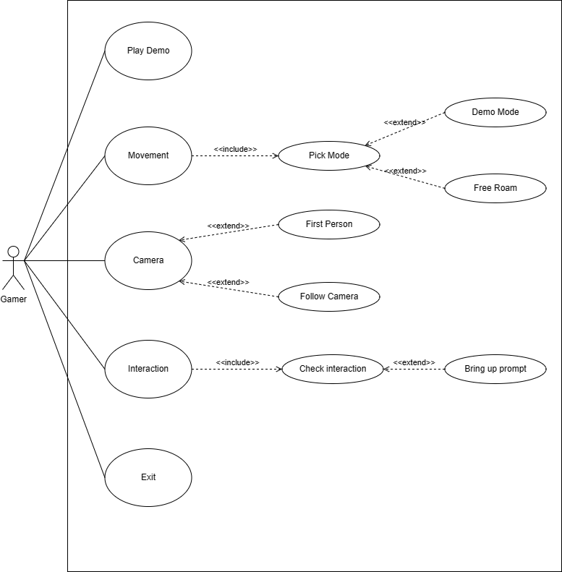

Figure 1: Use Case Diagram

### UML Sequence Diagram

A UML sequence diagram shows the sequence of messages between objects in a system. The main purpose of a UML sequence diagram is to show a visual representation of the dynamic behavior of a system (Lucid Software, 2018).

Below is a Figure 2: UML Sequence Diagram which is a UML sequence diagram for the project. It shows the interaction between a game object within the game world. When the player gets near an object that is interactable, a sequence of events will see if the object that the player is near is interactable or not. If it is intractable, then the player should get a prompt of some kind. If the object is not interactable, then nothing should happen, and the game should allow the player to move around the world with no prompt showing up.

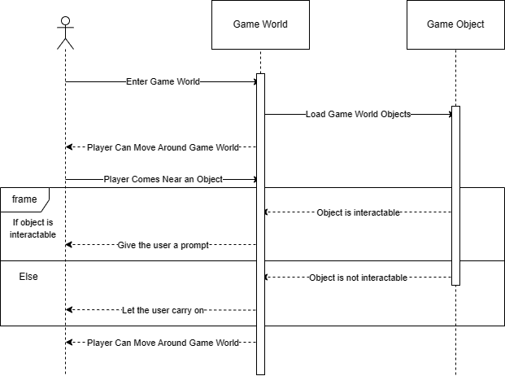

Figure 2: UML Sequence Diagram

### UML Class Diagram

A UML class diagram gives the user a visual representation of the classes in the system. It shows the attributes and methods of the classes. It shows the relationship between the classes. It shows the system’s structure, and it also illustrates the objects and classes that make up the system. UML class diagrams are a very important tool for designing and documenting a system by helping developers visualize and communicate the structure and behavior of the system to the stake holders and team members (Lucid Software, 2017).

Below is Figure 3 - UML Class Diagram which is a basic UML Class diagram for the project. This most likely will change as the development continues. There are 3 main classes Game, Player, and World. The game class manages the other 2 classes Player and World. The player class is the main character that is controllable by the player. World class is a game world which contains objects. objects can be interacted with if they are interactable. The camera class is the view in the game and the player sees the game world through the camera. The camera can be controlled to move around and show the game world.

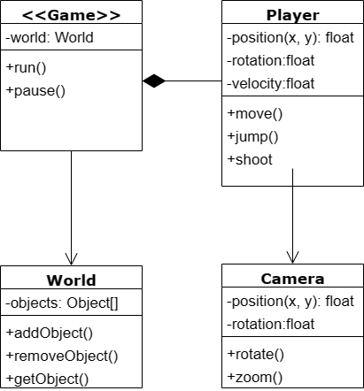

Figure 3 - UML Class Diagram

### Wireframe of UI

A wireframe is a visual representation of the layout and structure of an application such as a website, application, or a game. Wireframes are typically created in the early stages of the development process, and they usually change over time as it is just a mockup of the final design. The main purpose of a wireframe is to show the basic outline of a product and to be as simple so that everyone, such as the stake holders and programmers can understand it (Gemayel, 2019).

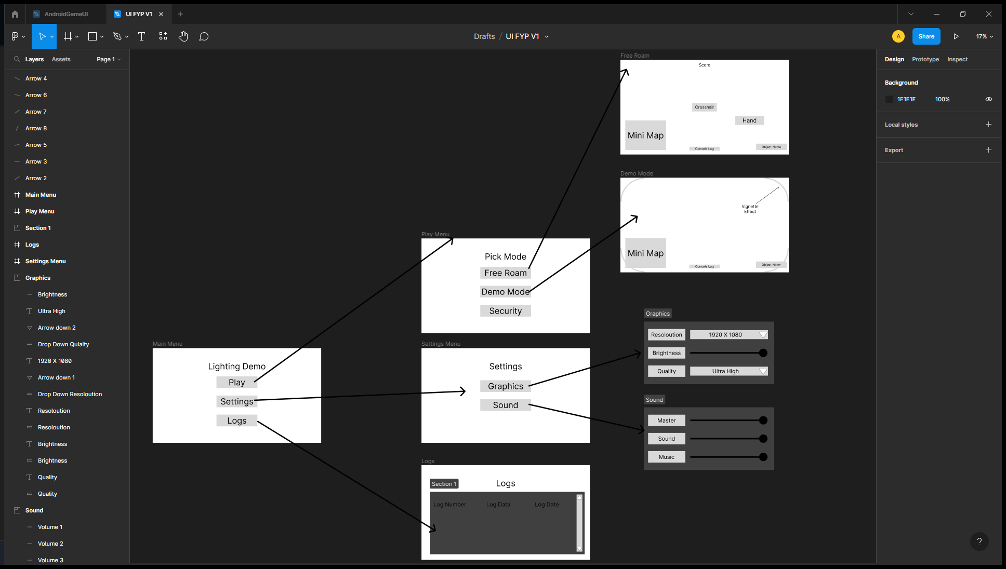

Figure 4 - Overall View in Figma Studio

This is the overall view of the user interface. This shows the flow of the user interface. When you press a button, it shows what the next step will be.

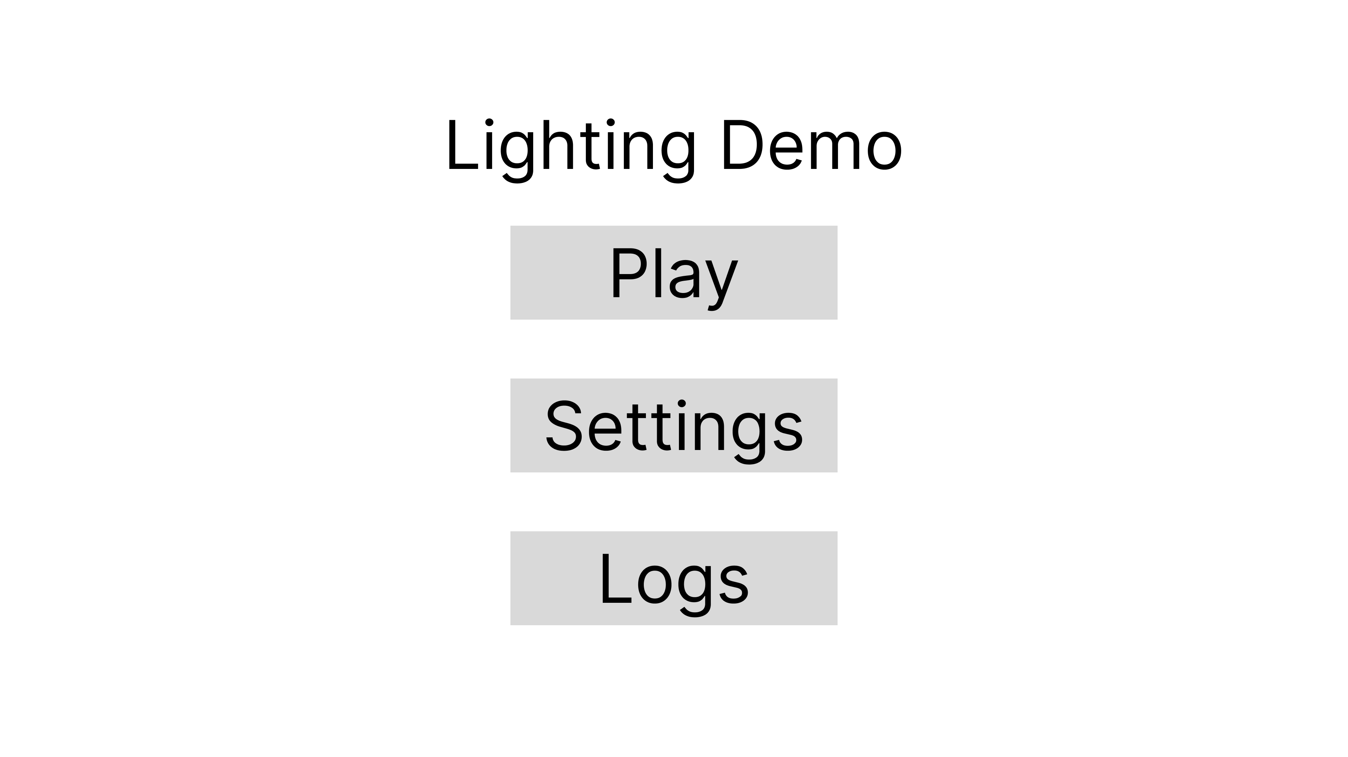

Figure 5 - Main Menu

This is the main menu of the game, it gives three options, Play, Settings and Logs. The play button will go to the play Menu where the player can pick the mode that they want to go into. The settings button will take the user to the settings menu. The logs button will send the user to the log menu to see any issues that may come up.

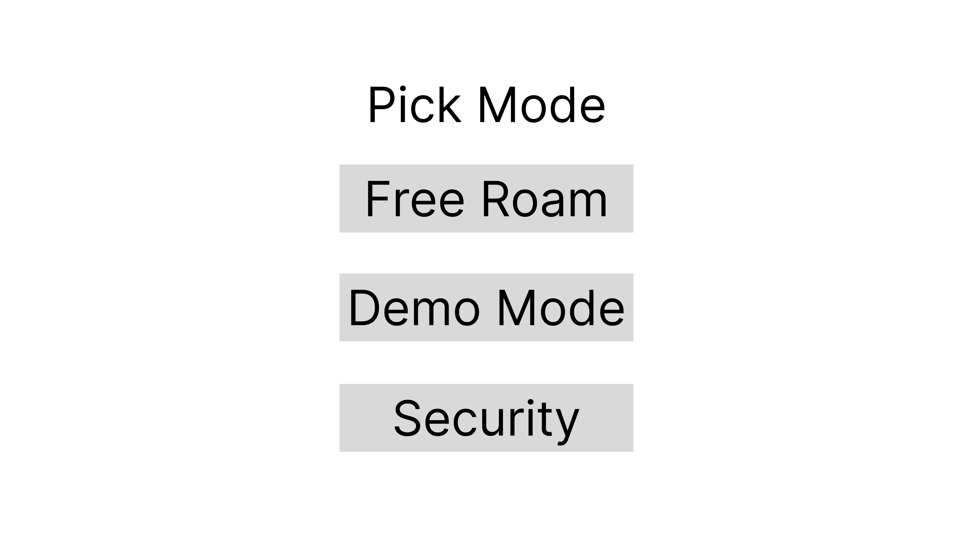

Figure 6 - Play Menu

This is the play menu. The user has 3 modes to pick from. The Free roam mode will allow the user to explore the entire game world. The demo mode will be a curated mode where the camera will move around the world on its own and shows the lighting effects in the game demo. The security button will show the user a small security demo.

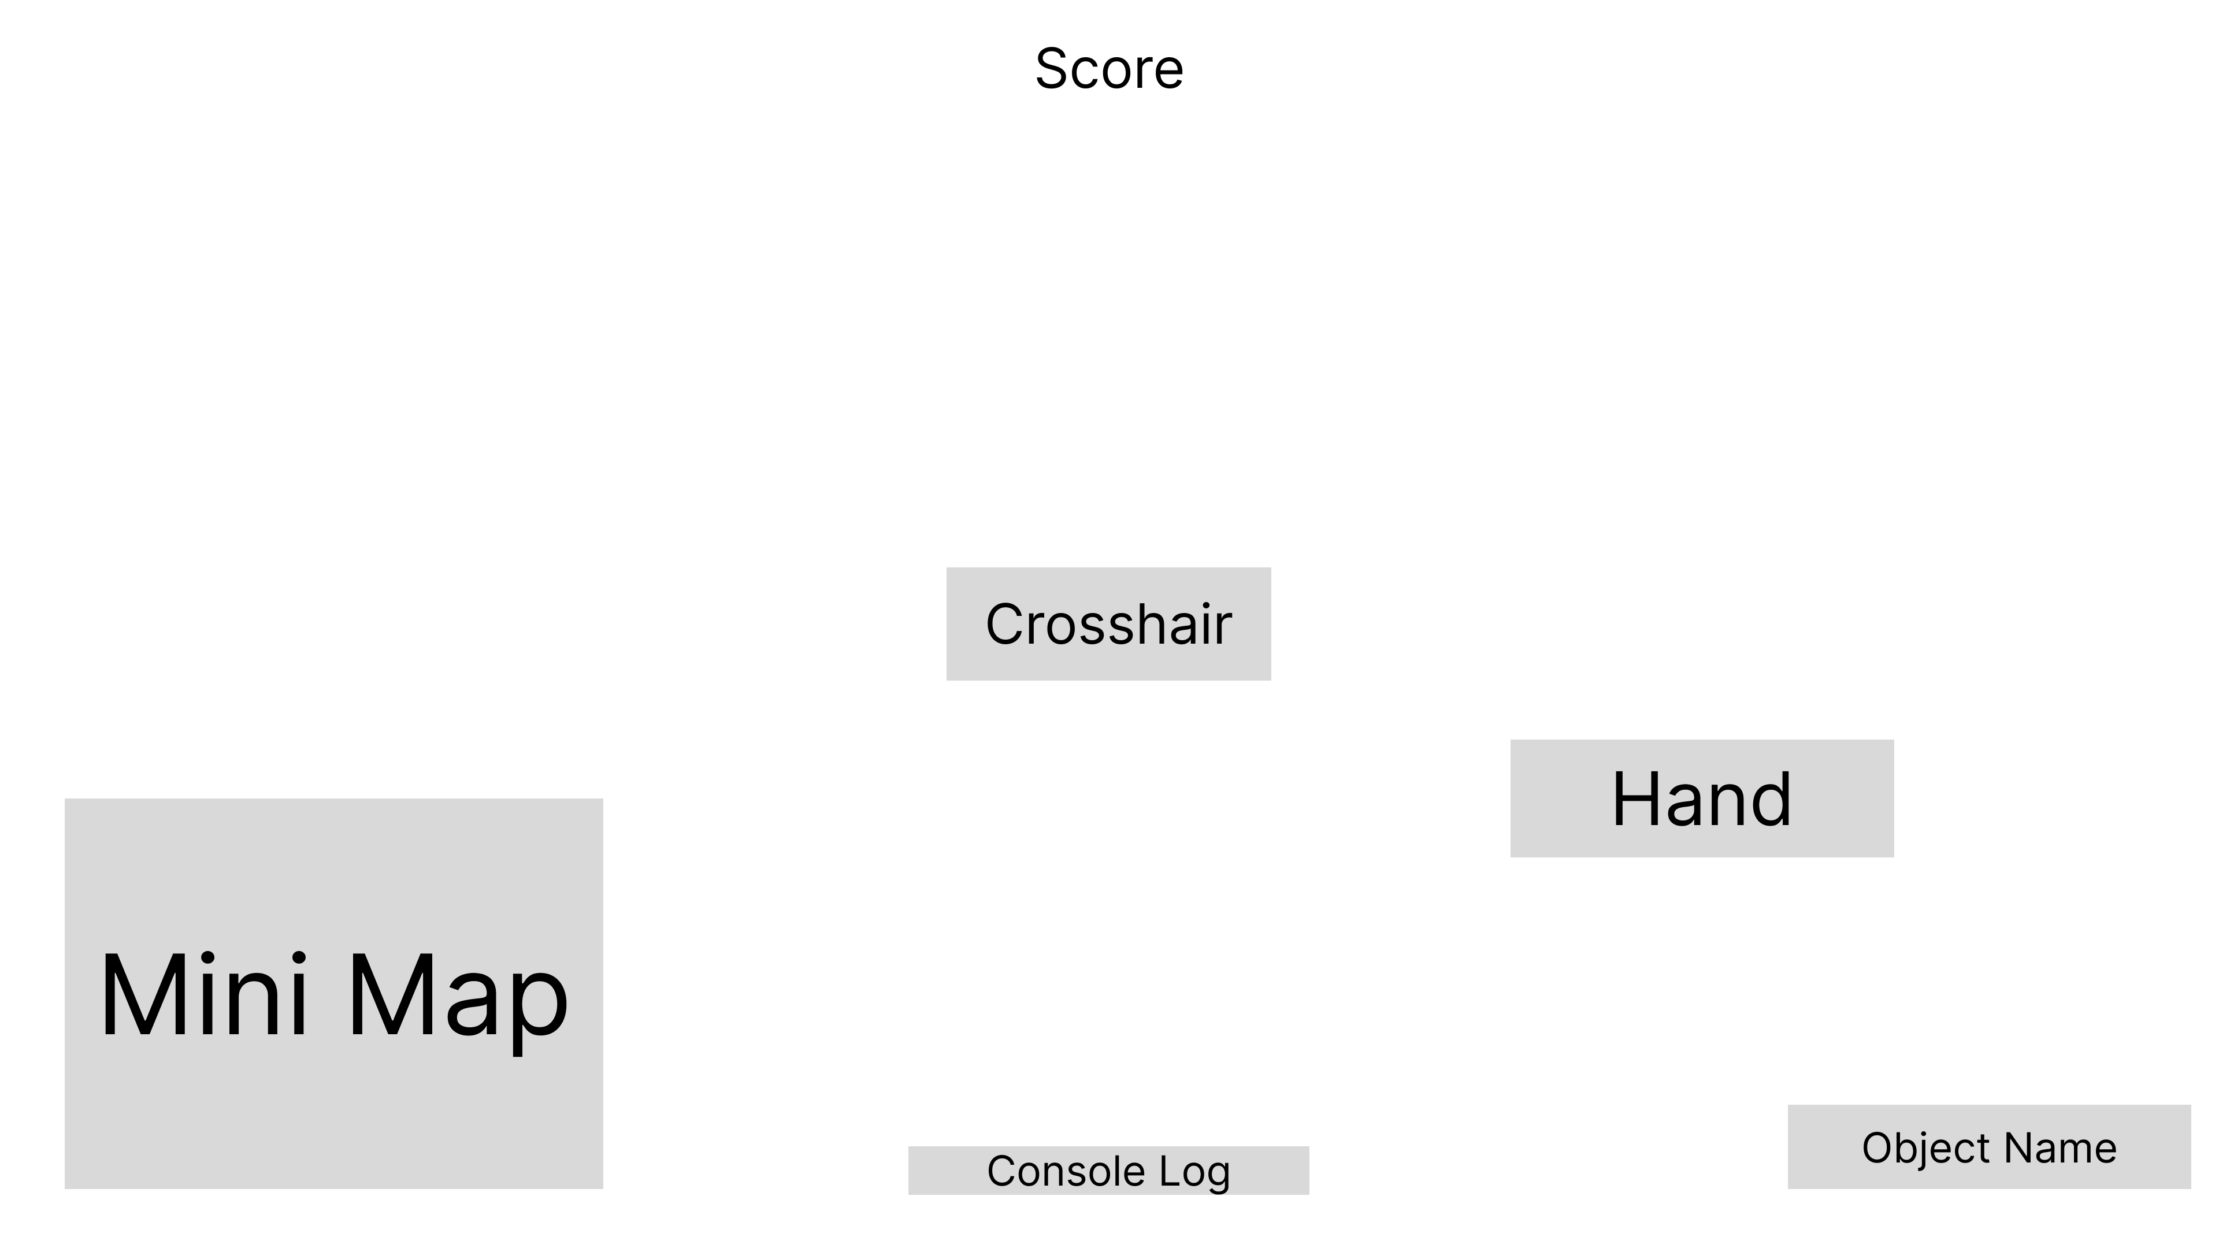

Figure 7 - Free Roam

This is the free roam wireframe.

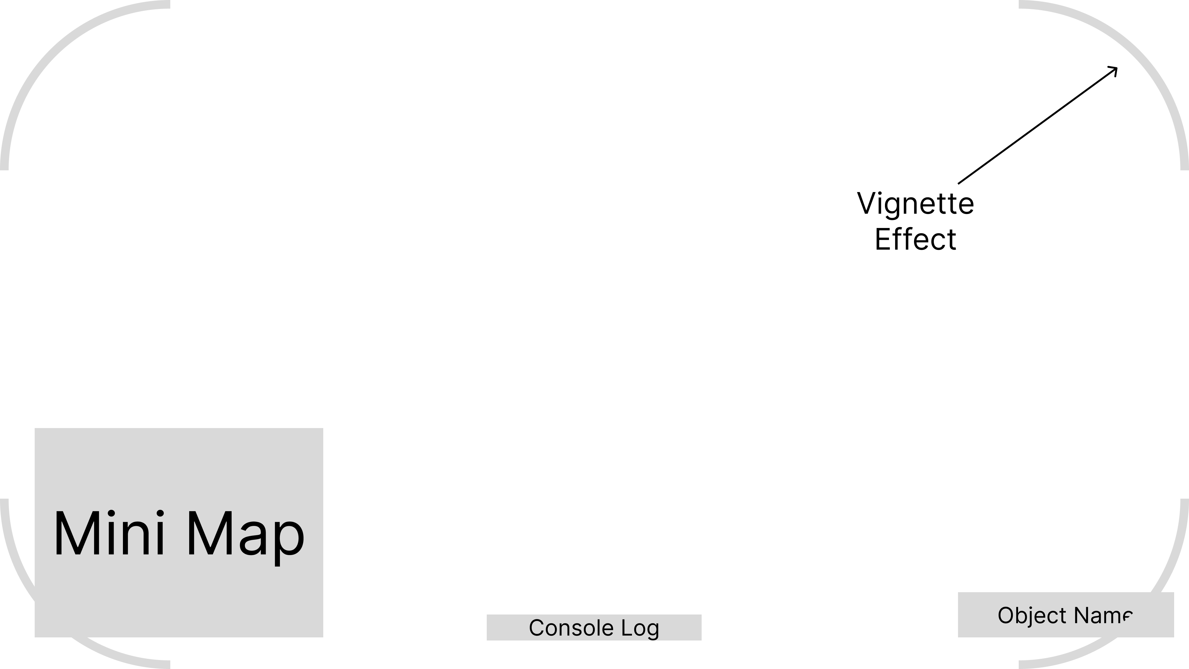

Figure 8 - Demo Mode

This is the demo mode wireframe.

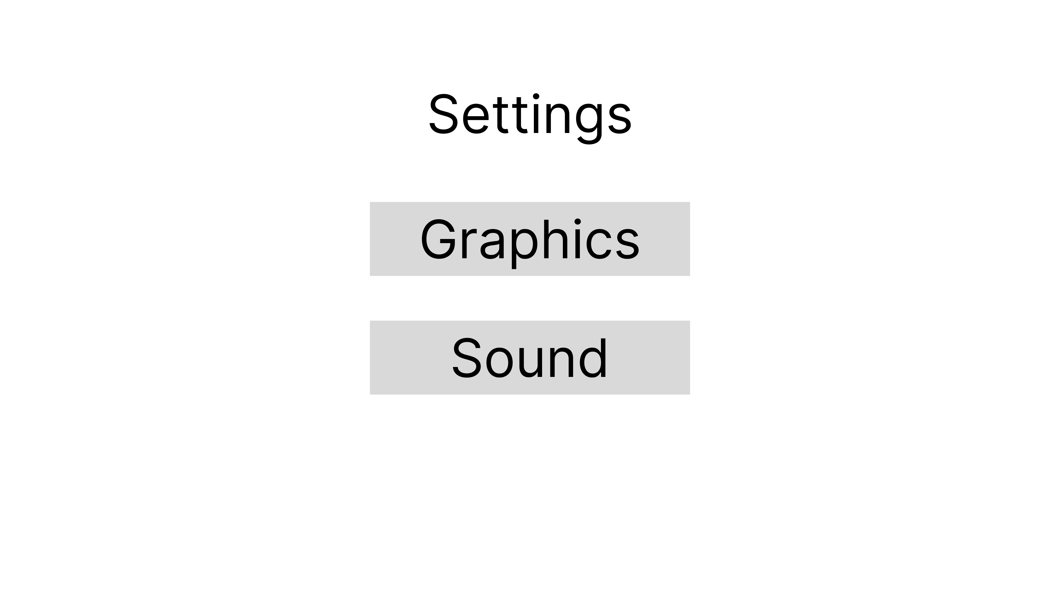

Figure 9 - Settings Menu

This is the settings menu. When the player clicks on graphics button a popup menu will open with the graphics settings. When the user clicks on the sound button, the sound popup menu will show.

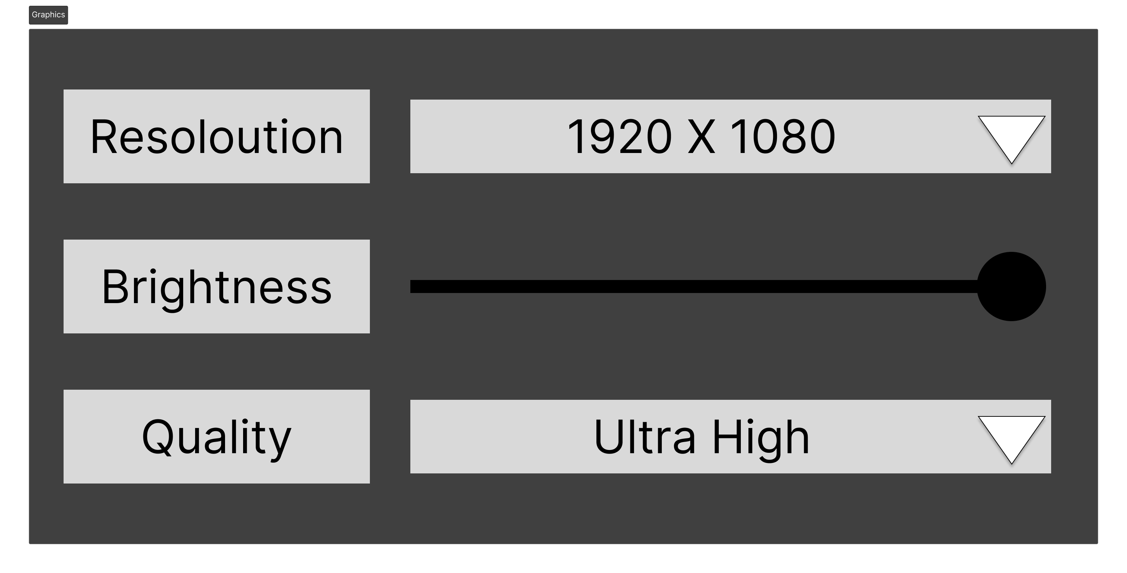

Figure 10 - Graphics Submenu

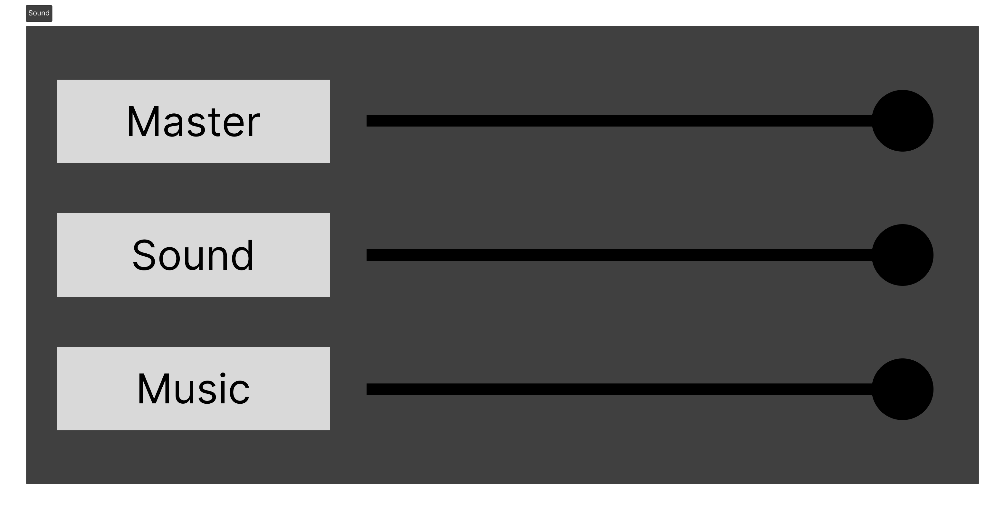

Figure 11 - Sound Submenu

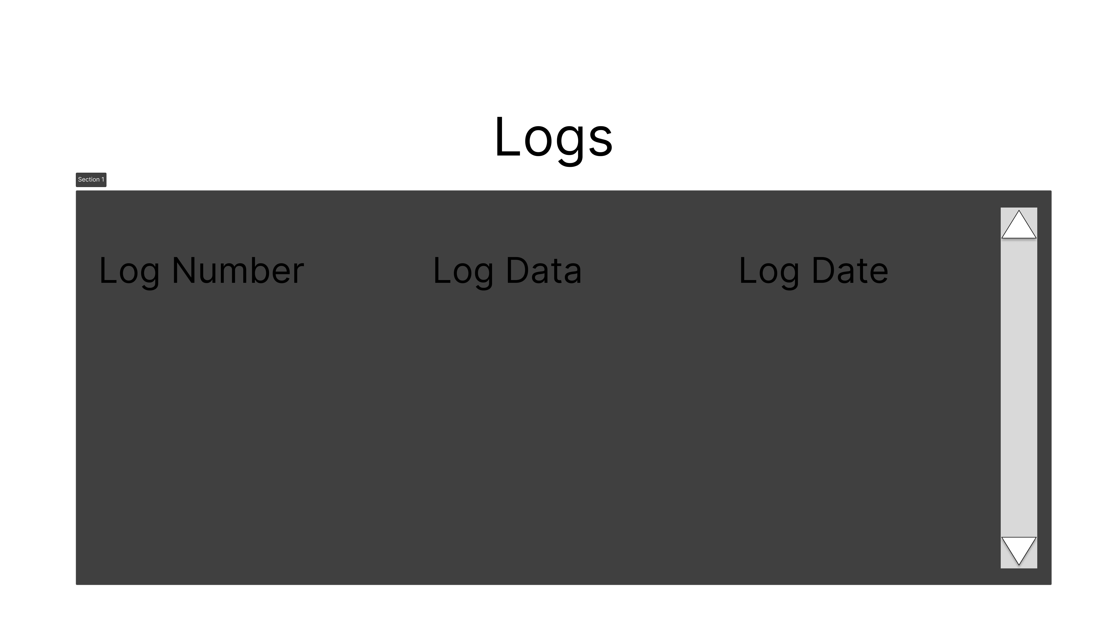

Figure 12 – Logs

This will be a debugging area so that it will be easier to find bugs and errors that happen in the game.

## Summary

The design of the game demo has been simplified to mainly focus on the lighting effects, which is the main purpose of the project. Also, the user interface is simple and easy to follow so that the user can quickly get in and out of the different parts of the demo so they can quickly see the entire demo.

# Development and Implementation

## Sprint 1 – MVP for Demo

## Sprint 2 – Final Release

## Security Research

## Obstacles during Development

# Testing and Analysis

## Testing

## Usability Testing

## Functional Testing

## Real world User Testing

## Platform Testing

## Regression Testing

## Build Testing

## Issues

# Critical Evaluation

# Conclusion

# References

1-up. (2021, March 08). *Turning Movement into Gameplay*. Retrieved from Medium: https://medium.com/@1-UP/turning-movement-into-gameplay-video-game-systems-428791dac211#:~:text=Movement%20systems%20are%20the%20means,environmental%20obstacles%20in%20their%20way.

Alexander, A. (2018, May 11). *Working on Lighting for Video Games*. Retrieved from 80lv: https://80.lv/articles/working-on-lighting-for-video-games/

BARI, M. A. (2023, February 7). *GTA Online PC Exploit Allows Hackers To Access IP Address, Rockstar Looking Into It*. Retrieved from Twisted Voxel: https://twistedvoxel.com/gta-v-gta-online-pc-update-online-security-fix-exploit/

Computer Hope. (2021, December 04). *Computer Hope*. Retrieved from Computer Hope: https://www.computerhope.com/jargon/b/battle-pass.htm

Criddle, C. (2021, February 9). *Cyberpunk 2077 makers CD Projekt hit by ransomware hack*. Retrieved from BBC: https://www.bbc.co.uk/news/technology-55994787

Gemayel, T. (2019, August 12). *How to wireframe.* Retrieved from Figma: https://www.figma.com/blog/how-to-wireframe/

Lucid Software. (2017, July 21). *UML Class Diagram Tutorial.* Retrieved from Youtube: https://www.youtube.com/watch?v=UI6lqHOVHic

Lucid Software. (2018, August 27). *https://www.youtube.com/watch?v=pCK6prSq8aw.* Retrieved from Youtube: https://www.youtube.com/watch?v=pCK6prSq8aw

Lucid Software. (2018, February 17). *UML Use Case Diagram Tutorial.* Retrieved from Youtube: https://www.youtube.com/watch?v=zid-MVo7M-E

Pease, A. (2021, February 8). *A Timely Hack: The Story Of CD Projekt RED’s Fall From Grace*. Retrieved from Argon Research: https://aragonresearch.com/cd-projekt-red-hack/#:~:text=On%20February%208th%2C%20CDPR%20announced,a%20dark%20web%20auction%20site.

Pluralsight. (2014, March 15). *Light Up Your World: How Lighting Makes All the Difference for Games*. Retrieved from Pluralsight: https://www.pluralsight.com/blog/film-games/understanding-the-importance-of-lighting-for-games#:~:text=Light%20has%20a%20drastic%20effect,keep%20the%20player%20on%20edge.

Pluralsight. (2014, April 22). *What Makes a Good Video Game? 4 Key Elements*. Retrieved from Pluralsight: https://www.pluralsight.com/blog/film-games/what-makes-a-great-game-the-key-elements-of-successful-games#:~:text=Graphics%20are%20extremely%20important%20for,and%20feel%20of%20the%20game.

Run, J. a. (2019, July 01). *Run, Jump and Climb: Designing Fun Movement in Games*. Retrieved from Game Developer: https://www.gamedeveloper.com/audio/run-jump-and-climb-designing-fun-movement-in-games

SomeOrdinaryGamers. (2023, February 20). *Rockstar Games Needs To Fix GTA 5 Immediately...* Retrieved from Youtube: https://www.youtube.com/watch?v=T4suANqWzc8

TRAINOR-FOGLEMAN, E. (2021, December 29). *5 timeless principles of good game design for 2022*. Retrieved from Evercast: https://www.evercast.us/blog/game-design-principles#:~:text=Put%20simply%3B%20good%20game%20design,the%20world%20of%20the%20game.

1. <https://www.youtube.com/watch?v=bgyrrjmavy4&t=15s>
2. PlayStation 5 Box 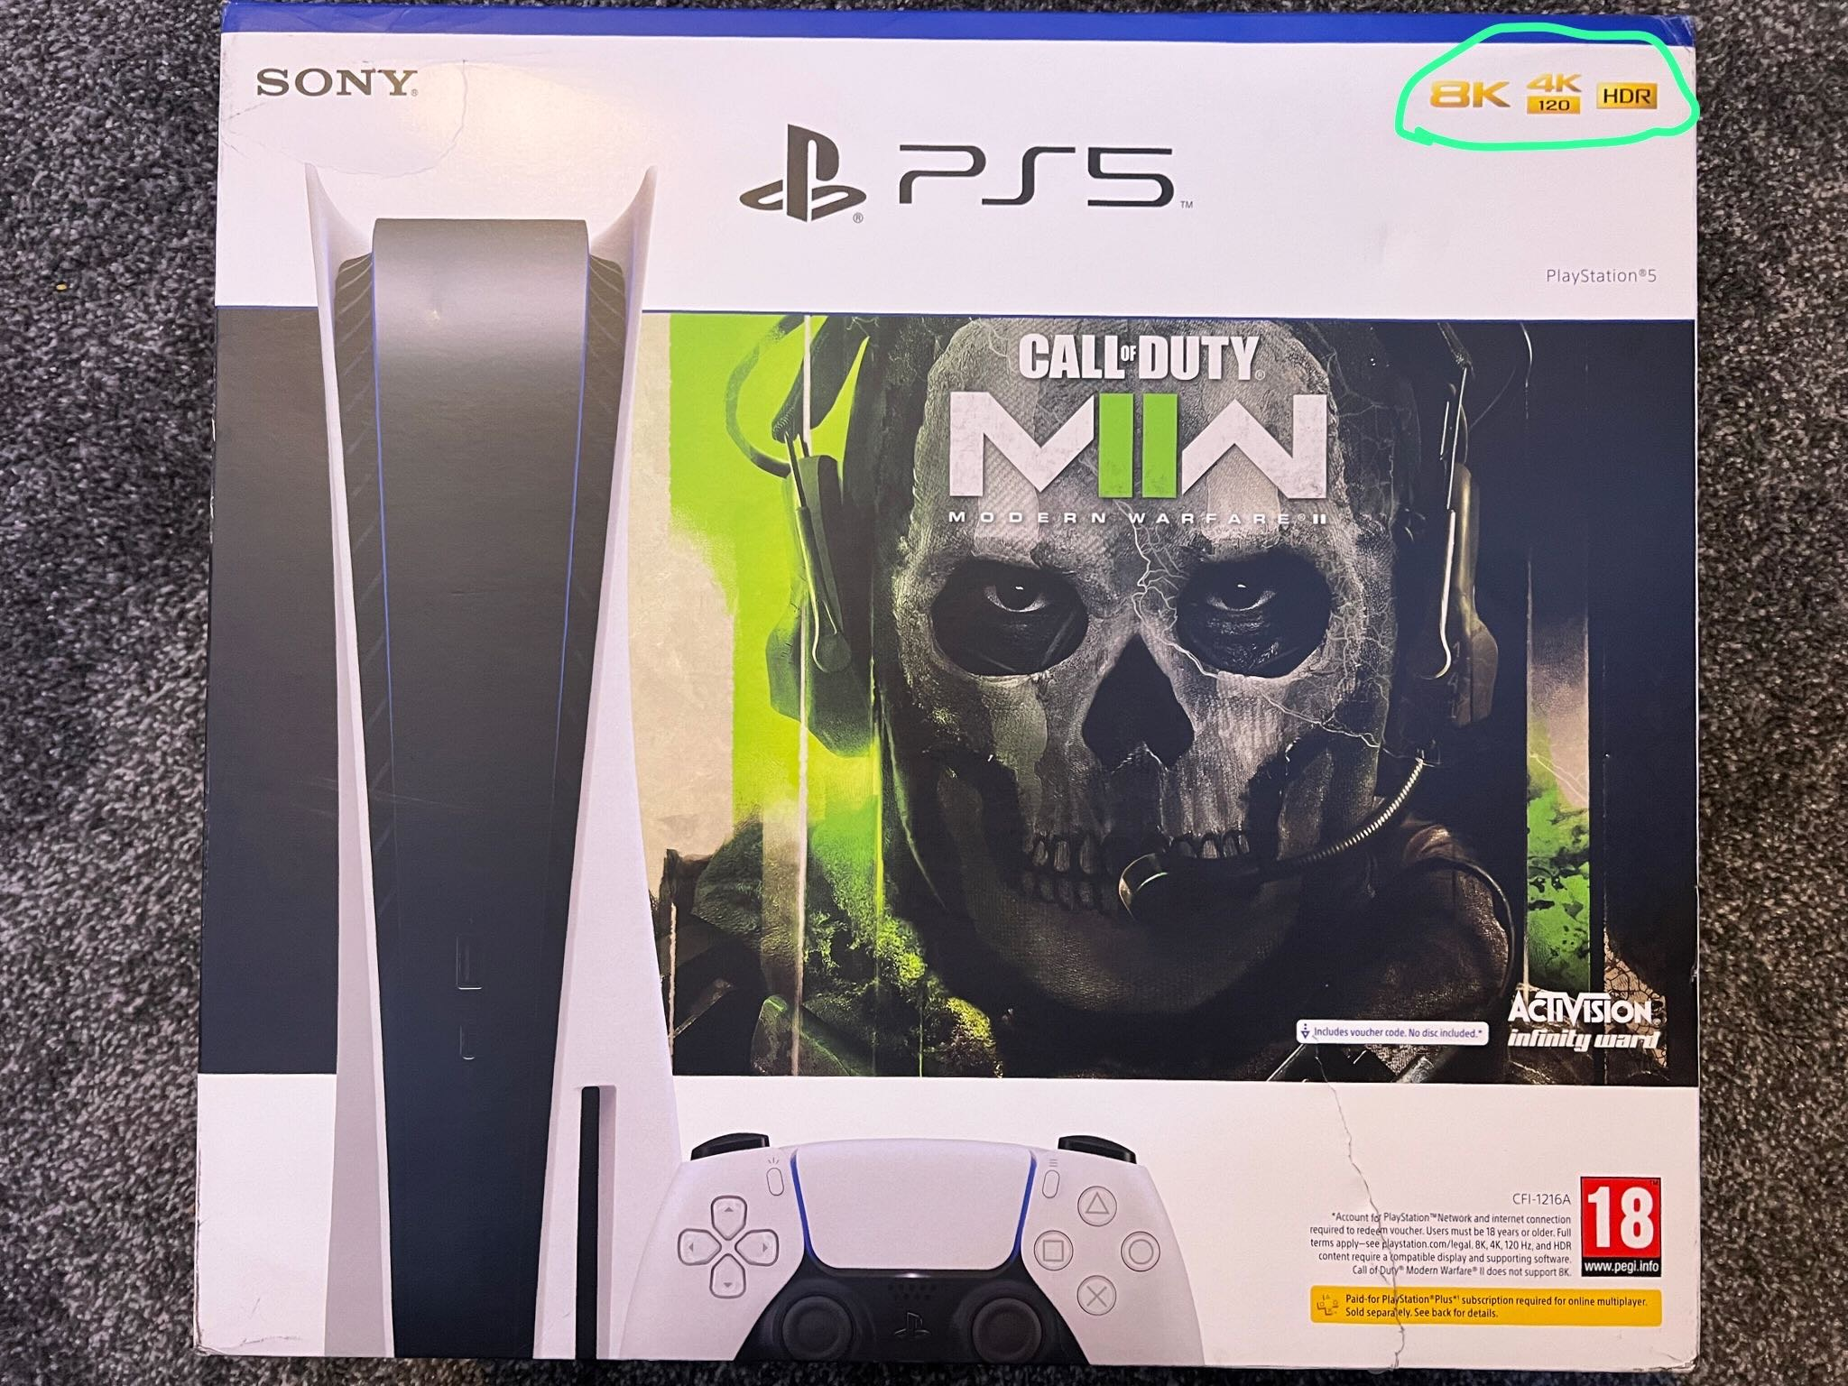
3. Call of Duty: Modern Warfare 2 2022 Battle Pass page: 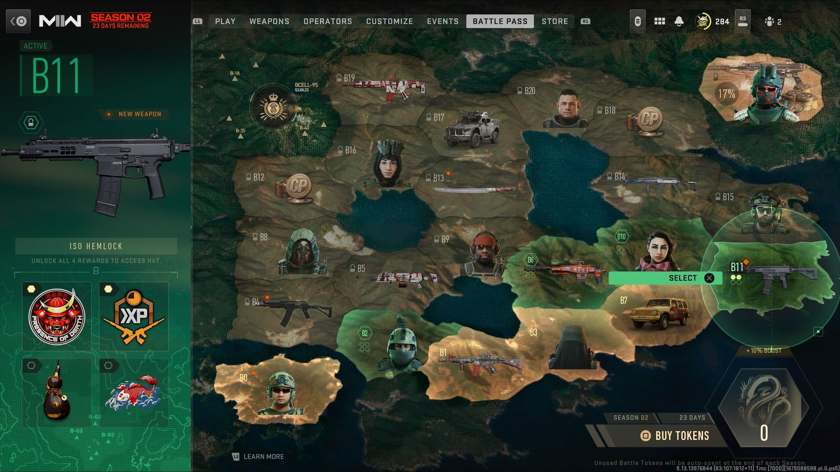
4. Battlefield 2042 Battle Pass page: 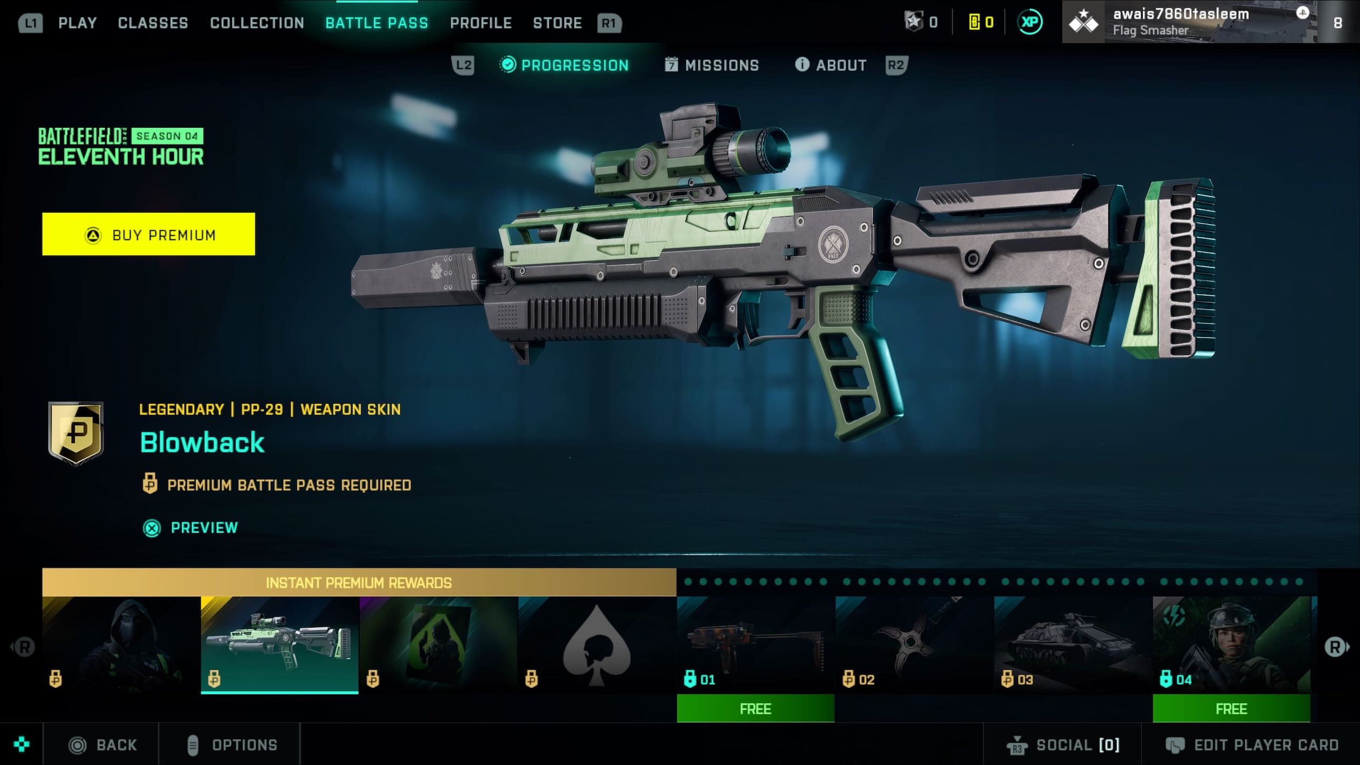
5. Shark Cash Card pirces and link to the website - [(rockstargames.com)](https://store.rockstargames.com/buy-gta-v-shark-cash-cards)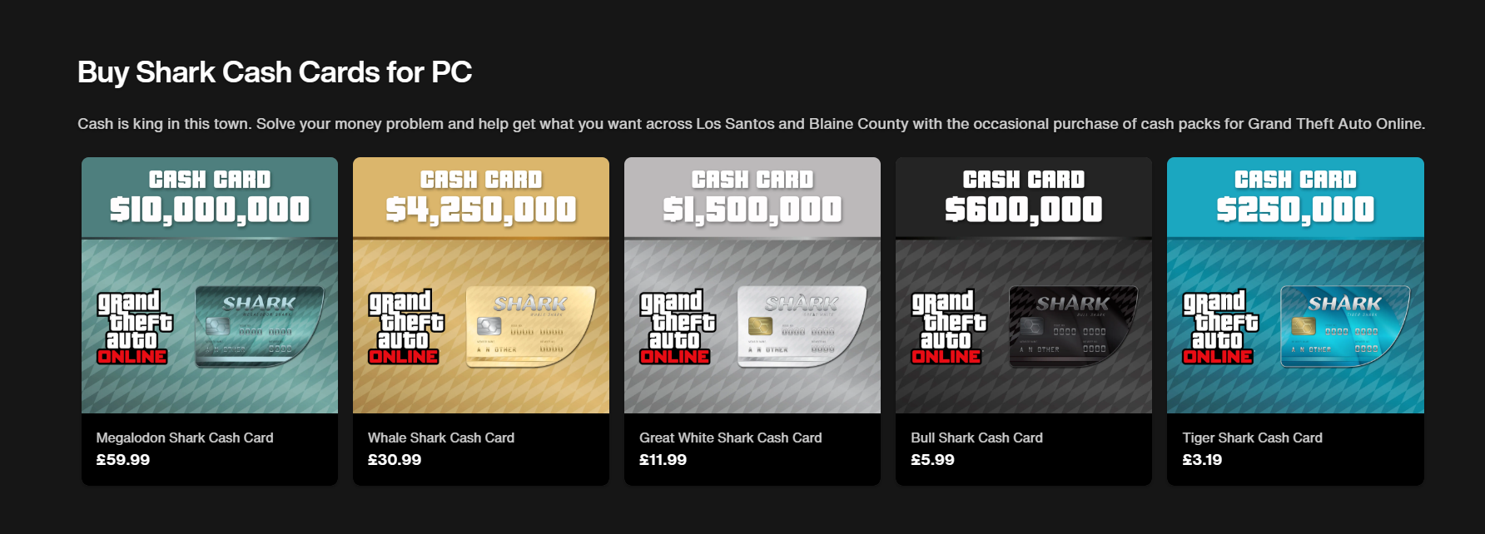
6. GTA 5 Mod Menu 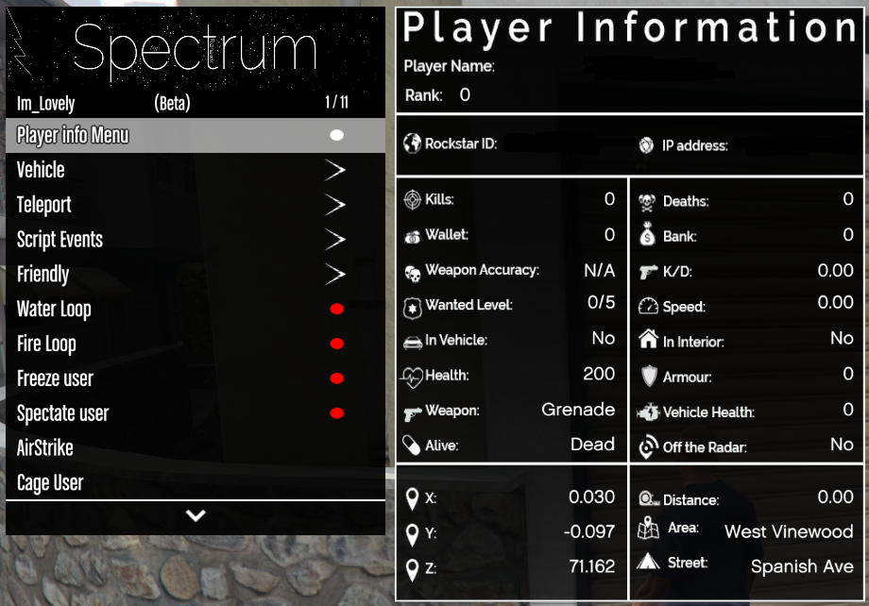
7. Figma - [Figma Downloads](https://www.figma.com/downloads/)

1. Draw.io link - [diagrams.net](https://app.diagrams.net/)